*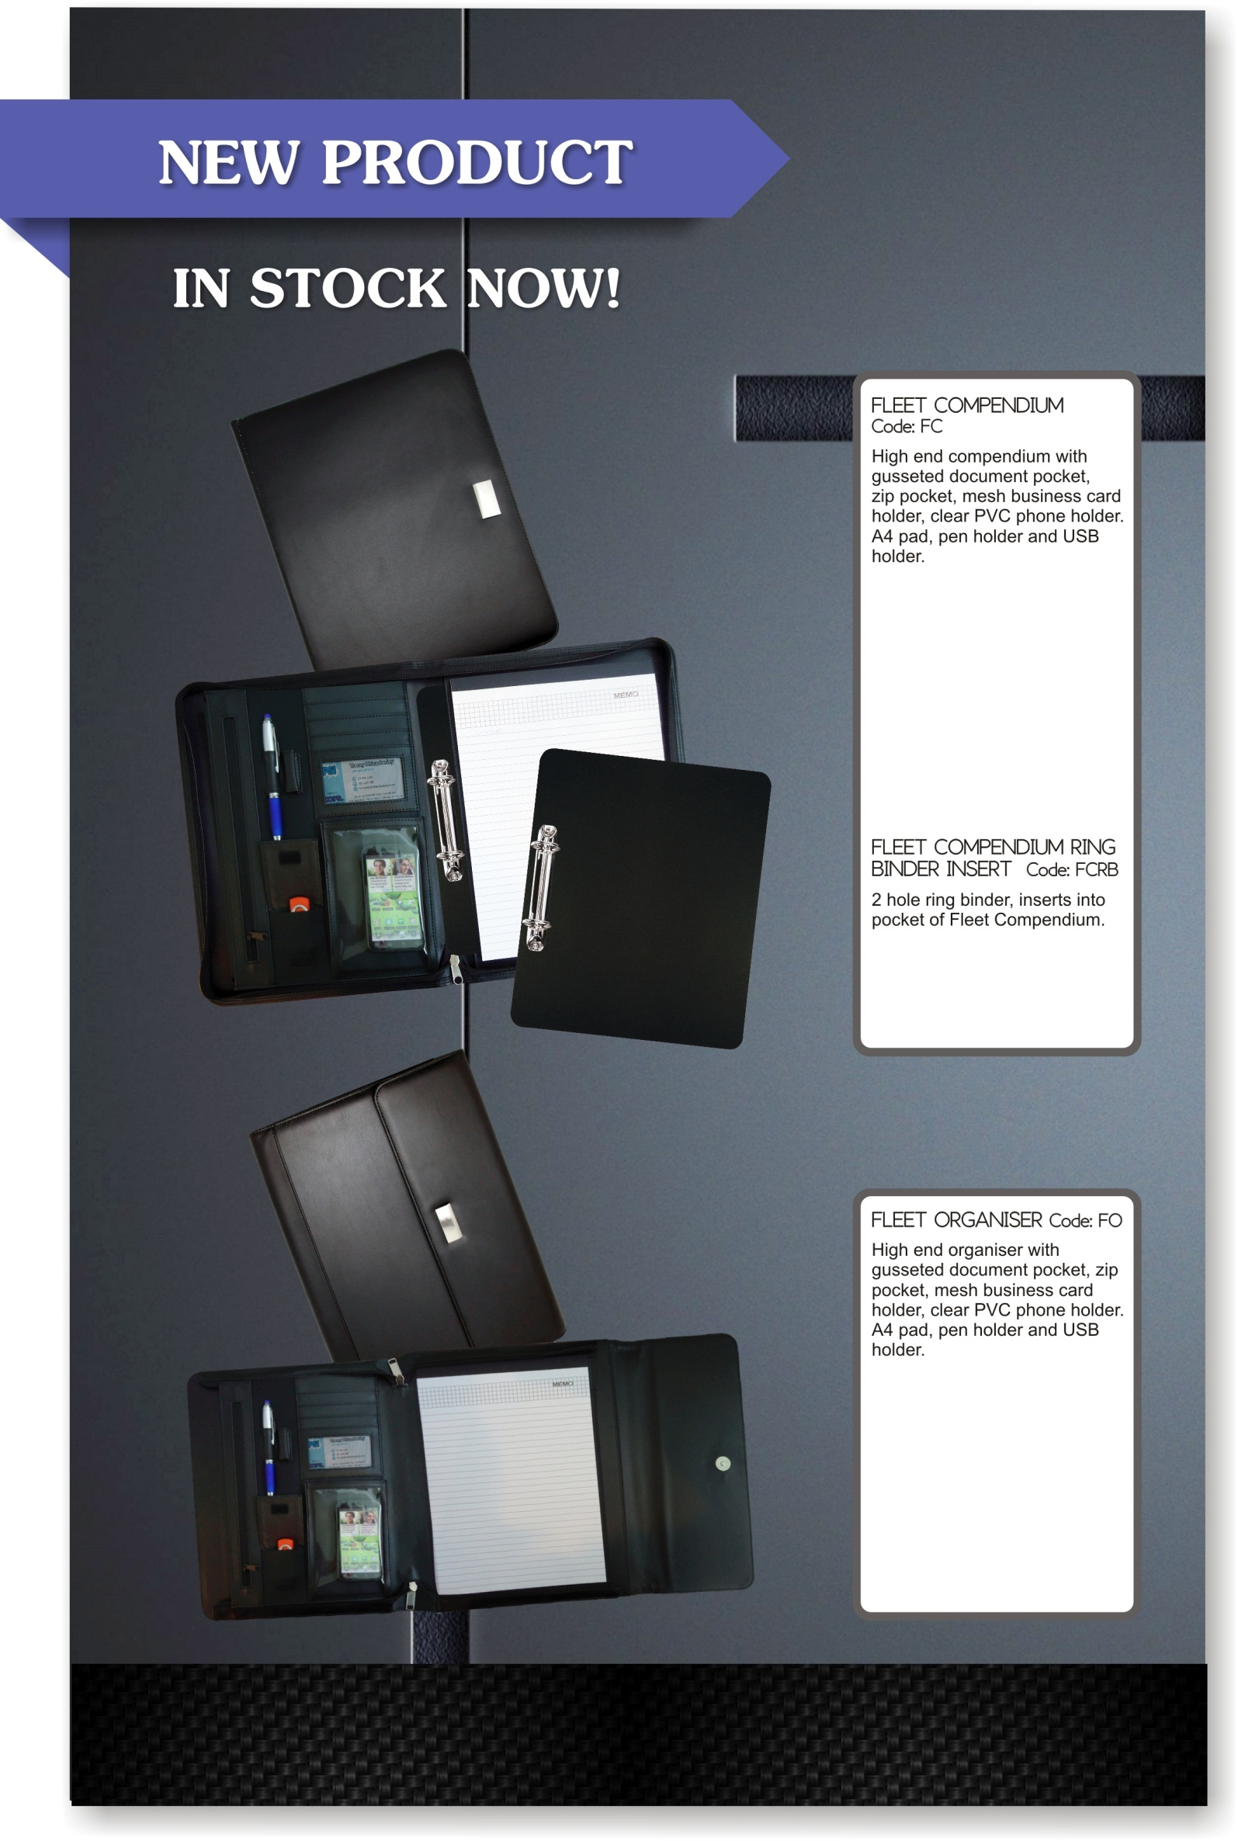*

****

Qty: Price $

25 43.30

50 40.80

100 39.00

250 38.00

500 36.50

Print 3.00 per col/pos, plus setup and G.S.T

Qty: Price $

25+ 3.00

Plus GST.

Qty: Price $

25 30.50

50 29.00

100 28.50

250 27.50

500 26.00

Print 3.00 per col/pos, plus setup and G.S.T

Calendars. Promotional Products & Corporate Gifts

Gifts for Business Waikato Ltd

Contact Peter 0274 817 873 – E [peter@g4b.co.nz](mailto:peter@g4b.co.nz) www.g4b.co.nz

wwwww